UCS 1302 Data Structures

Tutorial 3 on Graphs

--Dr. B. Prabavathy

***17.12.2021***

There is a **directed graph** of n colored nodes and m edges. The nodes are numbered from 0 to n - 1.

You are given a string colors where colors[i] is a lowercase English letter representing the **color** of the ith node in this graph (**0-indexed**). You are also given a 2D array edges where edges[j] = [aj, bj] indicates that there is a **directed edge** from node aj to node bj.

A valid **path** in the graph is a sequence of nodes x1 -> x2 -> x3 -> ... -> xk such that there is a directed edge from xi to xi+1 for every 1 <= i < k. The **color value** of the path is the number of nodes that are colored the **most frequently** occurring color along that path.

Return *the* ***largest color value*** *of any valid path in the given graph (K3, CO4)*

**Example 1:**

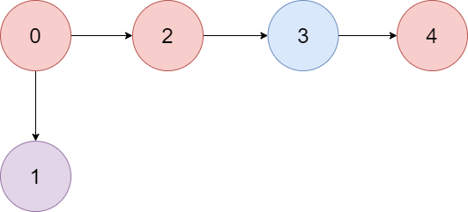

**Input:** colors = "abaca", edges = [[0,1],[0,2],[2,3],[3,4]]

**Output:** 3

**Explanation:** The path 0 -> 2 -> 3 -> 4 contains 3 nodes that are colored "a" (red in the above image).